Metabase Charts Documentation

Index
Micro-missions 3
1. How to find the data 3
1.1. Micro-missions Over Time 3
2. Taking/ Leaving with chain and Kilometers of shuttles and satellites 4
2.1. Taking/ Leaving with chain 5
2.2. Daily Taking/ Leaving with chain 6
2.3. Daily Taking/ Leaving with chain 7
2.4. Kilometers traveled 8
3. Results 9
3.1. Amount of the most serious results 10
3.2. Average time to conclude a micro mission 11
3.3. Date/Time and Average Time of a specific result 12
3.4. Type of missions that return a specific result 13
4. Battery variation 13
4.1. Hourly battery trend for all machines 14
4.2. Battery trend per minute of a day 15
4.3. Battery trend per minute 16
5. Number of missions 17
5.1. Total missions 18
5.2. Daily total missions 19
5.3. Hourly missions in a specific day 20
Alarms 21
1. How to find the data 21
1.1. In what time periods can you find data regarding alarms? 21
2. Association Alarms/Micro missions 22
2.1. Micro-mission types and results linked to alarm types and descriptions 23
3. Alarm Count by Type and Description 24
3.1. Alarms triggered 25
3.2. Number of alarms triggered based on Mission Type and Machines 26
3.3. Daily number of alarms 27
3.4. Number of alarms by type 28
3.5. Alarm quantity based on alarm type and machines 29
3.6. Daily number alarms triggered 30
Appunti Errore. Il segnalibro non è definito.

Micro-missions

1. How to find the data
In this section there is only one chart, and that permit to research the data regarding the Micro-missions over time.

1.1. Micro-missions Over Time
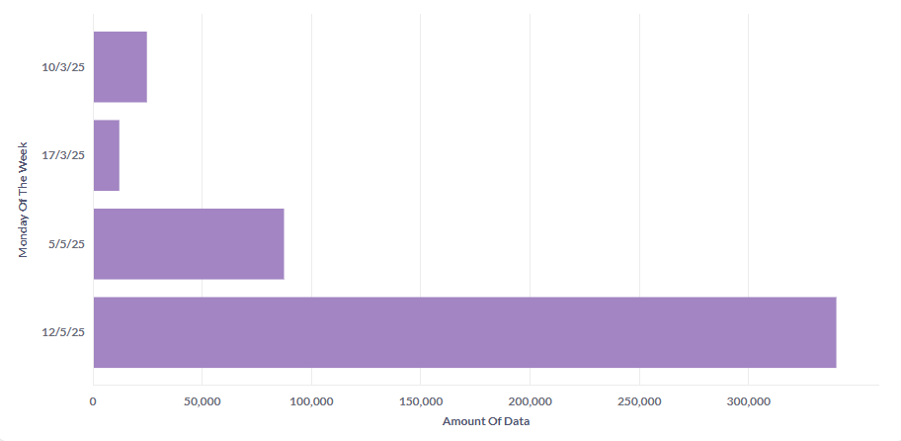
Description:
This chart illustrates the time availability of Micro missions’ data, for a specific job order.
Each bar corresponds to the Monday of the reference week and indicates the number of records in the database for that week.
This visual representation helps identify periods with higher or lower data availability.

Goals:
- Identify the time range during which data is available for a specific job order.
- Display the volume of data available for each week.
- Help users select an appropriate time filter by providing an initial overview of data availability, thus reducing the need for trial-and-error.

Filters to customize the chart:
- Job

2. Taking/ Leaving with chain and Kilometers of shuttles and satellites
In this section there are four charts related to micro-missions of type (10) Taking with chain, (20) Leaving with chain and the distance in kilometers covered by the machines.

2.1. Taking/ Leaving with chain
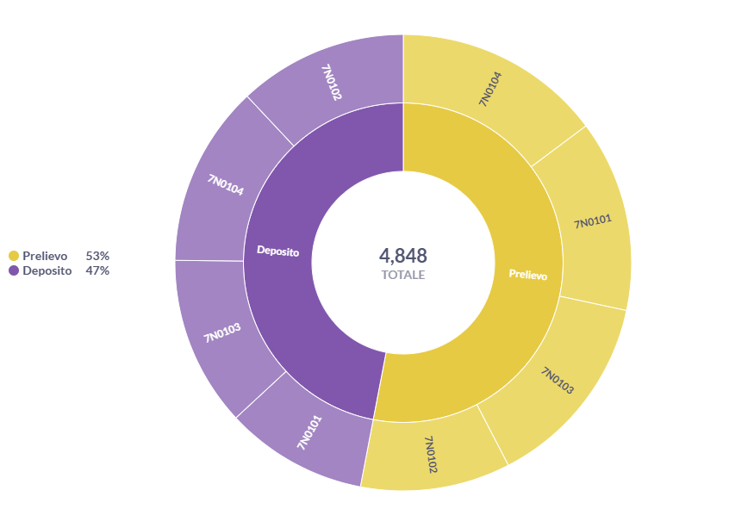
Description:
This chart illustrates the number of Taking with Chain and Leaving with Chain missions performed by each selected machine.
It compares missions of type (10) Taking with Chain and (20) Leaving with Chain, performed by each selected machine, which resulted in either (1) OK or (21) OK silent warning, for a specific job order.

Goals:
- Compare the total number of Taking versus Leaving operations
- Compare the number of Taking operations performed by different machines
- Compare the number of Leaving operations performed by different machines
- Compare the number of Taking and Leaving operations performed by a single machine

Filters to customize the chart:
- Job
- Machine (multi-select)
- Time Range

2.2. Daily Taking/ Leaving with chain
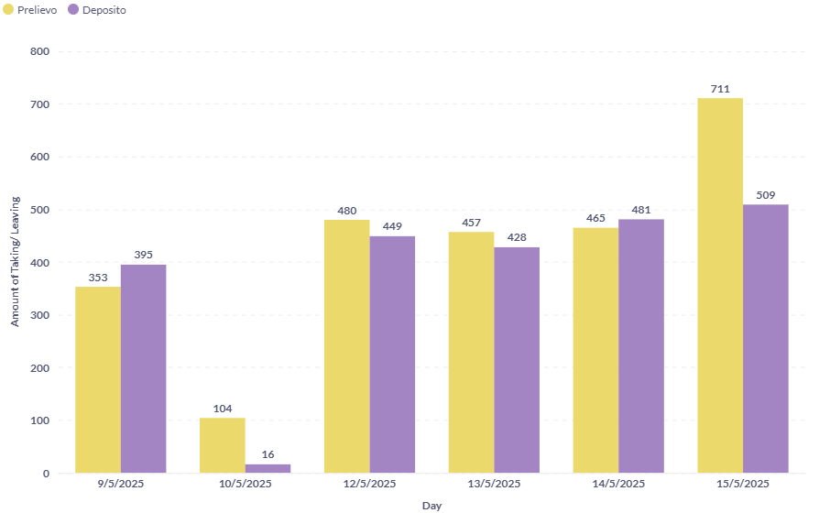
Description:
This chart illustrates the daily number of the Taking with Chain and Leaving with Chain operations performed by all selected machines.
It compares daily missions of type (10) Taking with Chain and (20) Leaving with Chain, performed by all selected machines, which resulted in either (1) OK or (21) OK silent warning, for a specific job order.

Goals:
- Compare the number of Taking operations performed on different days
- Compare the number of Leaving operations performed on different days
- Compare the number of Taking and Leaving operations performed on a single day

Filters to customize the chart:
- Job
- Machine (multi-select)
- Time Range

2.3. Daily Taking/ Leaving with chain
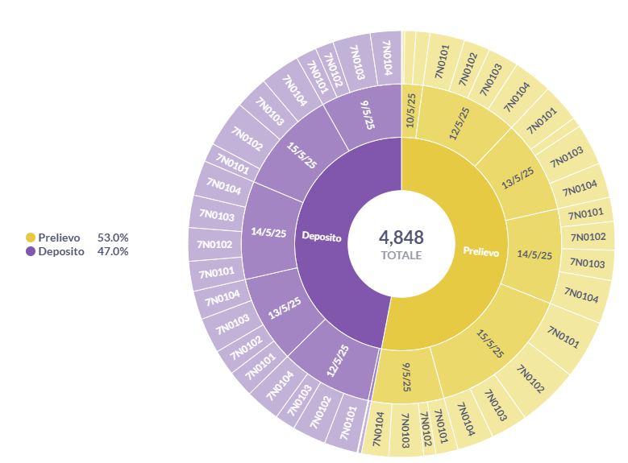
Description:
This chart illustrates the daily number of Taking with Chain and Leaving with Chain missions performed by each selected machine.
It compares daily missions of type (10) Taking with Chain and (20) Leaving with Chain, executed by each selected machine, which resulted in either (1) OK or (21) OK silent warning, for a specific job.

Goals:
- Compare the number of Taking vs Leaving operations:
  - Performed on the same day
    - On the same machines
    - On different machines
  - Performed on different days
    - On the same machines
    - On different machines
- Identify days with a high volume of operations

Filters to customize the chart:
- Job
- Machine (multi-select)
- Time Range

2.4. Kilometers traveled
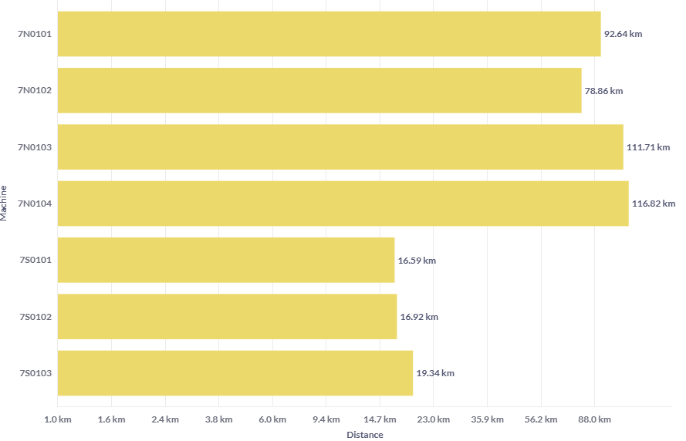
Description:
This chart illustrates the distances traveled by each selected machine.
It compares the distances covered by each selected machine during (30) Move missions which resulted in either (1) OK or (21) OK Silent Warning, for a specific job.
Goals: Analyze and compare the distance traveled by each machine.

Filters to customize the chart:
- Job
- Machine (multi-select)
- Time Range

3. Results
In this section there are four charts related to the results that the machines give us once a micro-mission has been completed.

3.1. Amount of the most serious results
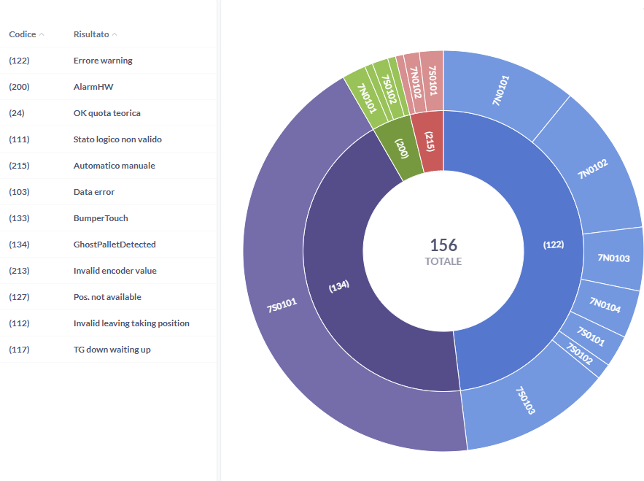
Description:
The legend links each code shown on the graph to a specific result.
This chart illustrates the number of results returned by machines, focusing on the most serious ones.
It compares the frequency of the following critical results for each selected machine:
(111) Invalid logical state, (112) Invalid position, (122) Error warning, (134) Ghost Pallet Detected, (200) Alarm HW e (215) Automatic manual.

Goals:
- Understand the total number of serious errors occurring.
- Identify the most frequent error types.
- Determine which machines are most affected by these errors.

Filters to customize the chart:
- Job
- Machine (multi-select)
- Time Range

3.2. Average time to conclude a micro mission
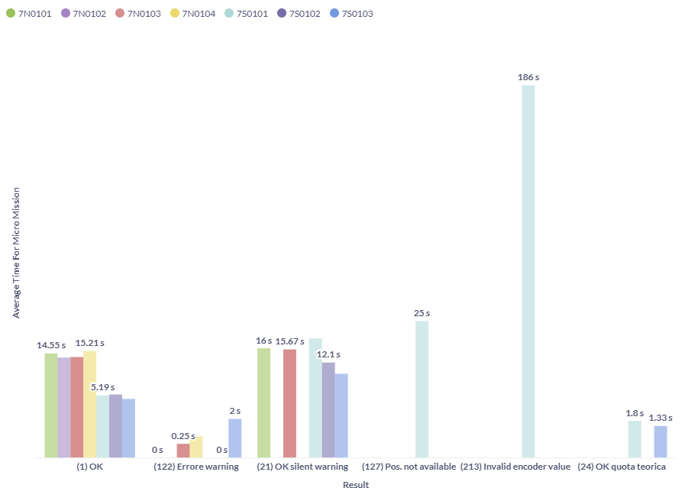
Description:
This chart illustrates the average processing time each selected machine took for each result.
It compares the average time across different results and machines. Additionally, it shows the total number of missions, total processing time, and number of micro missions for each machine and result.

Goals:
Identify any unwanted delays and understand:
- Which machines experienced them
- Which results are associated with them

Filters to customize the chart:
- Job
- Machine (multi-select)
- Time Range

3.3. Date/Time and Average Time of a specific result
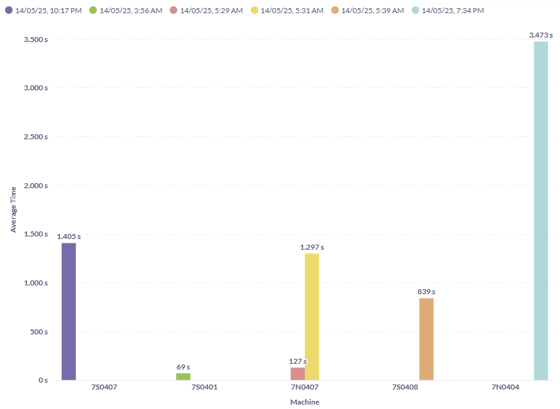
Description:
This chart illustrates the average time each selected machine took to process a specific result, along with the exact date and time the result was generated.
It compares the average processing time for that result across all selected machines and shows when and on which machine each occurrence happened.
Goals:
- Identify the exact date and time when the result occurred and on which machine.
- Compare the average processing times of the selected machines.
Filters to customize the chart:
- Job
- Result
- Machine (multi-select)
- Time Range

3.4. Type of missions that return a specific result
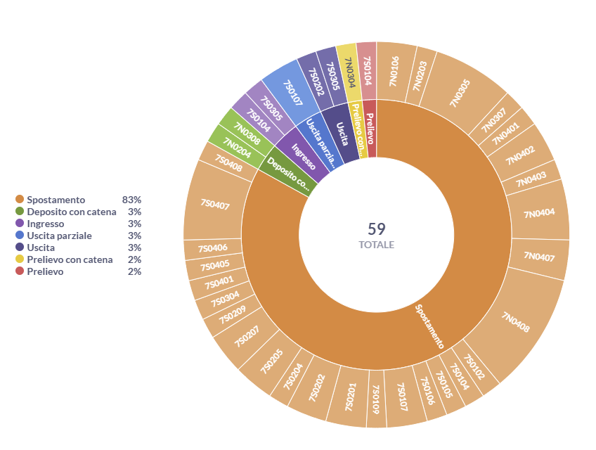
Description:
This chart displays the mission types that produced a specific result and identifies which machines performed those operations.
It compares the different mission types associated with the specific result and highlights the most significant one.
Goals:
- Determine in which types of micro-missions the result occurs most frequently.
- Identify the machines where the result occurs most often.
- Examine the combinations of machines and mission types linked to the result.
Filters to customize the chart:
- Job
- Result
- Machine (multi-select)
- Time Range

4. Battery variation
In this section there are three charts related to battery percentage variations.

4.1. Hourly battery trend for all machines
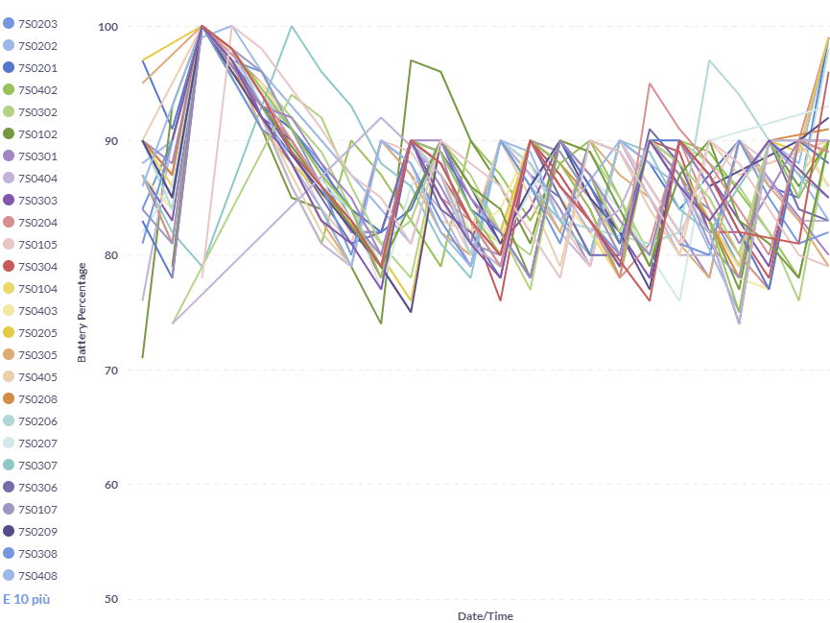
Description:
This chart illustrates the hourly battery trend of all machines involved in a specific job.
It allows us to identify any significant drops in battery levels and spot machines whose behavior differs from the overall pattern.
Note that this is an approximate trend, as it uses the maximum battery value recorded within each hour. For a more detailed view of battery fluctuations, refer to the additional support charts in the battery variations section.
Goal: Monitor the overall battery trends of all machines in a job order.

Filters to customize the chart:
- Job
- Time Range

4.2. Battery trend per minute of a day
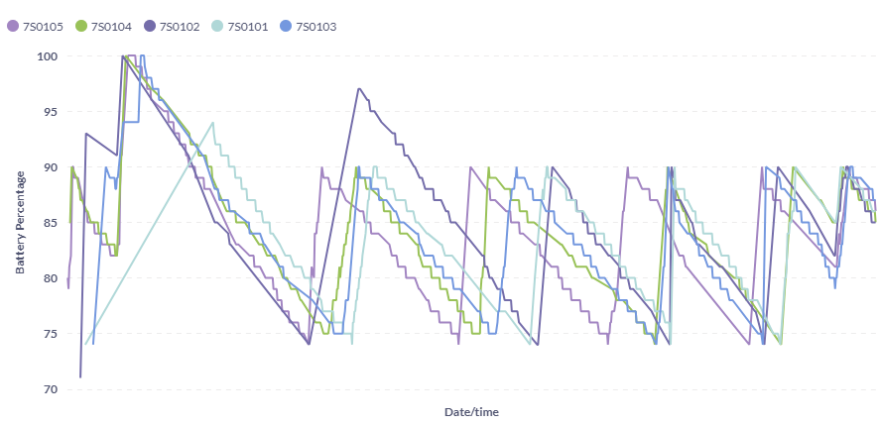
Description:
This chart illustrates the per-minute battery trend for each selected machine on a specific day.
It provides a high-resolution view of battery behavior over time, allowing for more precise analysis of fluctuations and usage patterns.
Goal: Analyze the battery levels of each machine in greater detail, minute by minute.
Filters to customize the chart:
- Job
- Specific Data
- Machine (multi-select)

4.3. Battery trend per minute
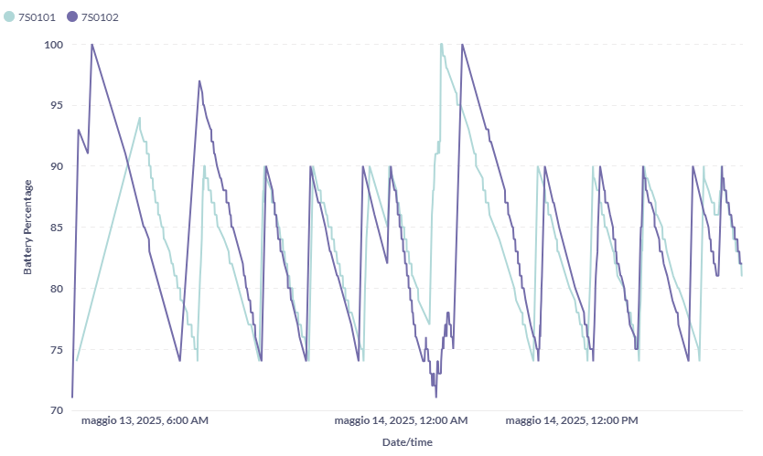
Description:
This chart illustrates the per-minute battery trend for each selected machine.
It provides a detailed view of battery behavior over time, enabling precise analysis within a custom time range.
Goal: Analyze battery levels minute by minute within a personalized time range for deeper insight.

Filters to customize the chart:
- Job
- Time Range
- Machine (multi-select)

5. Number of missions
In this section there are four charts related to number of missions carried out by the machine in a personalized period.

5.1. Total missions
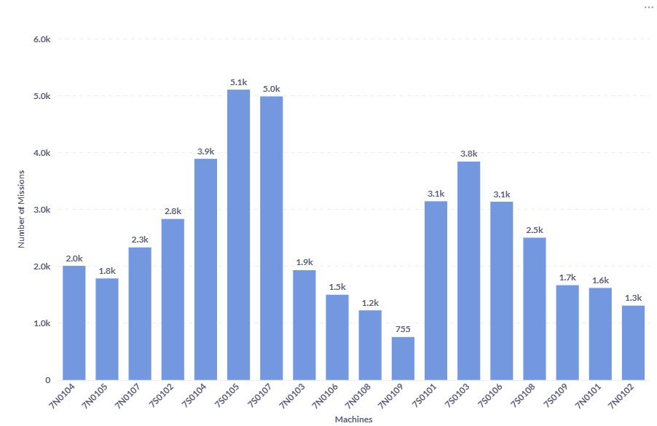
Description:
This chart illustrates the number of micro-missions performed by the selected machines within a given time interval.
It provides a clear view of the distribution of the workload, showing how many micro-missions each machine completed during that period.
Goals: Identify which machine has the highest workload.

Filters to customize the chart:
- Job
- Time Range
- Machine (multi-select)

5.2. Daily total missions
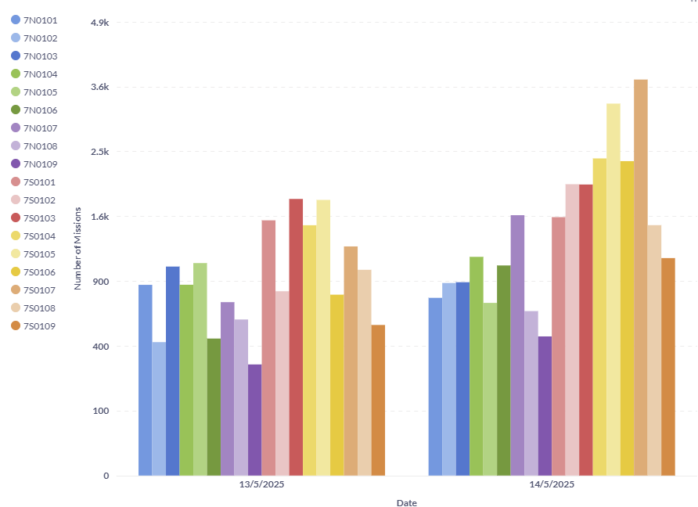
Description:
This chart illustrates the number of micro-missions performed by the selected machines over a specified time interval, broken down by day.
It shows the daily workload of each machine, making it easy to track how many micro-missions were completed by each one on each day.
Goals:
- Identify which machine has the highest workload per hour
- Compare the hourly workload patterns of the same machines throughout the day

Filters to customize the chart:
- Job
- Time Range
- Machine (multi-select)

5.3. Hourly missions in a specific day
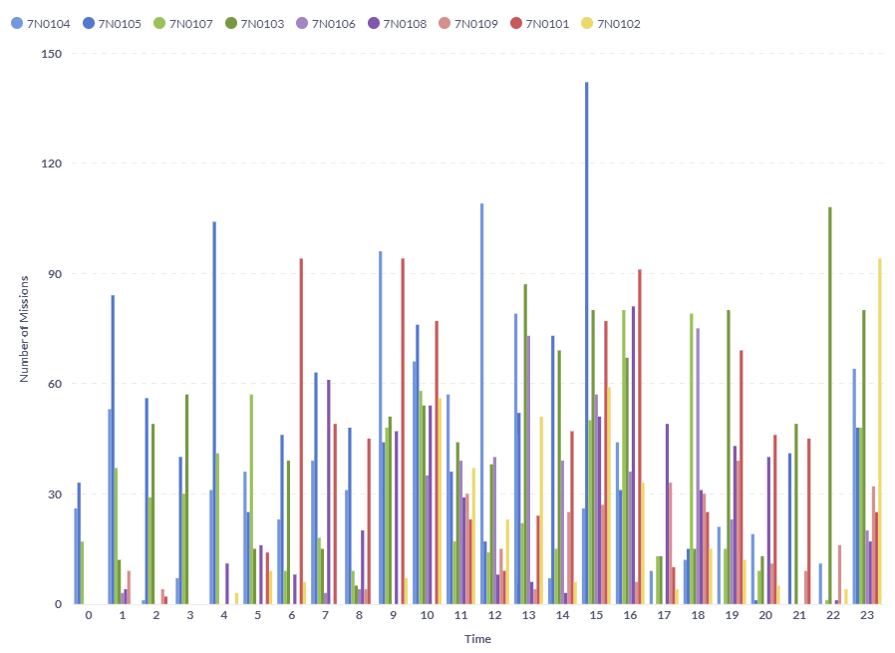
Description:
This chart illustrates the number of micro-missions performed by machines on a specific day, broken down by hour.
It shows how many micro-missions each machine completed during each hour, enabling detailed analysis of hourly activity and workload distribution.
Goals:
- Identify which machine has the highest activity level per hour
- Compare the number of micro-missions across different hours for the same machines

Filters to customize the chart:
- Job
- Data Specifica
- Machine (multi-select)

Alarms

1. How to find the data
In this section there is only one chart, and that permit to research the data regarding the Alarms.

1.1. In what time periods can you find data regarding alarms?
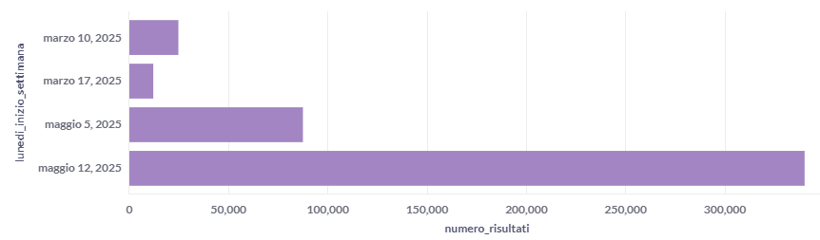
Description:
This chart illustrates the time availability of Alarms’ data, for a specific job order.
Each bar corresponds to the Monday of the reference week and indicates the number of records in the database for that week.
This visual representation helps identify periods with higher or lower data availability.

Goals:
- Identify the time range during which data is available for a specific job order.
- Display the volume of data available for each week.
- Help users select an appropriate time filter by providing an initial overview of data availability, thus reducing the need for trial-and-error.

2. Association Between Alarms and Micro-missions
In this section there is only one chart related to the coupling of Alarms and Micro-missions where we can find the data that provides us with a broader vision.

2.1. Details of Micro-mission and Alarm
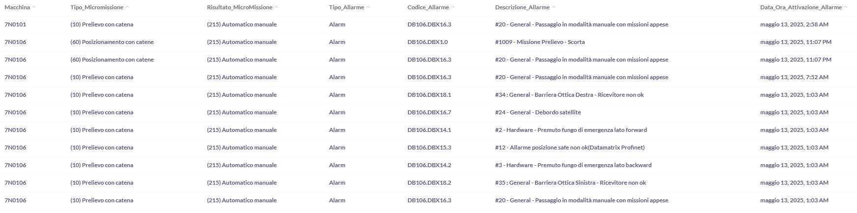
This view—more a table than a chart—associates alarms with the corresponding micro-missions.
It enables the identification of the specific alarm that occurred during a micro-mission, providing a more detailed error description in addition to the result returned by the machine at the end of that operation.

Each alarm includes:
- Alarm Type (Alarm, Silent Warning, or Warning)
- Alarm Code
- Alarm Description

Goal: Understand the exact alarm or error condition that triggered a specific result in a micro-mission

Filters to customize the chart:
- Job
- Time Range
- Machine (multi-select)
- Alarm Type
- Alarm Description

3. Alarm Count by Type and Description
In this section there are one chart related to the coupling of Alarms and Micro-missions where we can find the data that provides us with a broader vision.

3.1. Alarm Legend: Types, Codes, and Descriptions
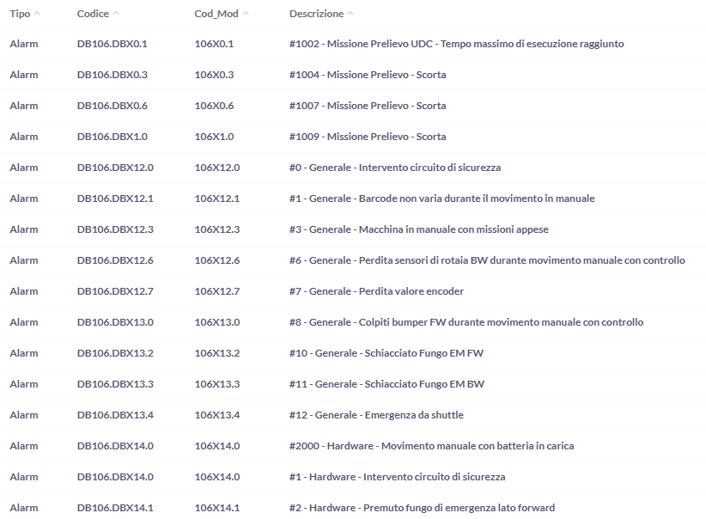
Description:
The table illustrates the type of alarm, its actual code, an abbreviated code that will be used in the graphs and a description.
Goals: Purpose of a legend, that is, to assign to each code an in-depth description.

Filters to customize the chart:
- Job
- Time Range
- Machine (multi-select)
- Alarm Type
- Alarm Description

3.2. Alarm Frequency by Mission Type and Machine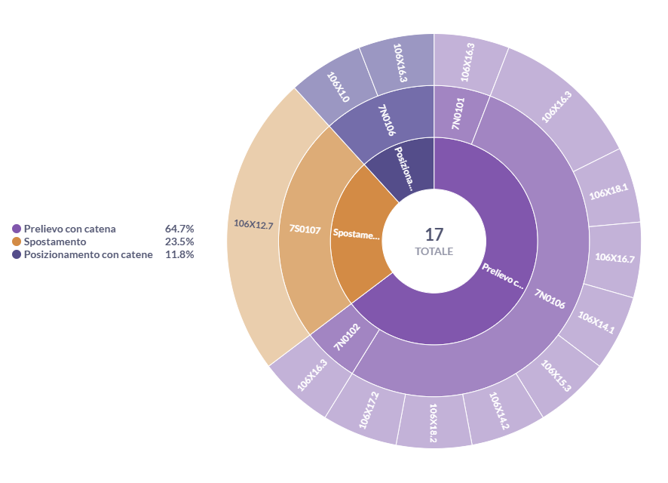
Description:
This chart shows the number of missions for each mission type and machine where a specific error code occurred.
It helps identify which mission types and machines experience these errors most frequently.
Goals:
Highlight the most frequent alarms by identifying:
- The specific mission types where they occur
- The machines affected
Filters to customize the chart:
- Job
- Time Range
- Machine (multi-select)
- Alarm Type
- Alarm Description

3.3. Daily Alarm Counts
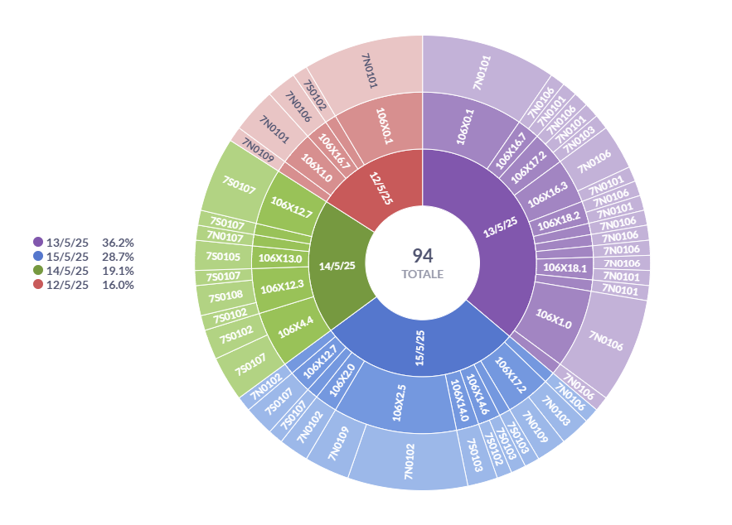
Description:
This chart shows the number of alarms recorded for each day within the selected time range.

Goals:
Identify the most frequent alarms by specifying:
- The specific day they occurred
- The machines involved

Filters to customize the chart:
- Job
- Time Range
- Machine (multi-select)
- Alarm Type
- Alarm Description

3.4. Alarm Counts by Type and Description
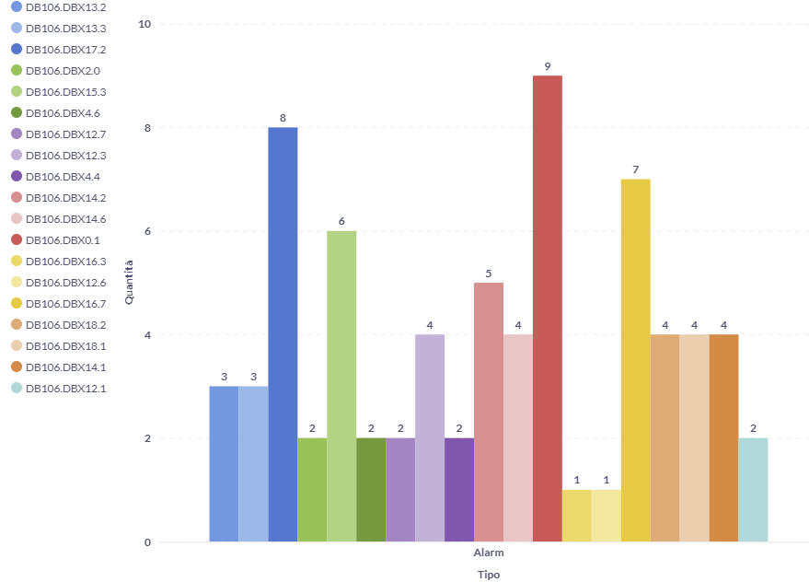
Description:
This chart displays the number of alarms categorized by type and description, regardless of which machines or days they occurred on.
Goals: Provide a general overview of the most frequently occurring types of errors
Filters to customize the chart:
- Job
- Time Range
- Machine (multi-select)
- Alarm Type
- Alarm Description

3.5. Number of Alarms based on alarm type and machines
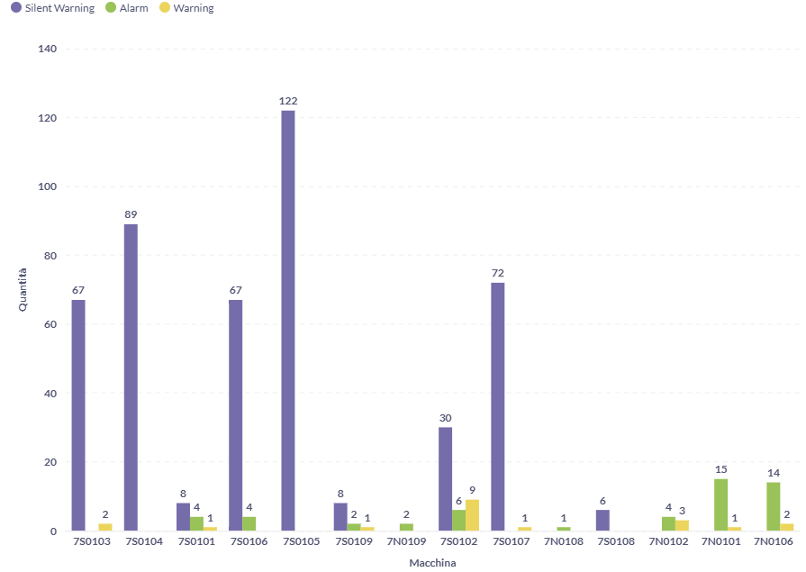
Description:
This chart shows the number of alarms recorded for each machine, broken down by alarm type.
Goals: Identify which machines experience the most errors based on the three possible alarm types.

Filters to customize the chart:
- Job
- Time Range
- Machine (multi-select)
- Alarm Type
- Alarm Description

3.6. Daily number alarms triggered for each machine
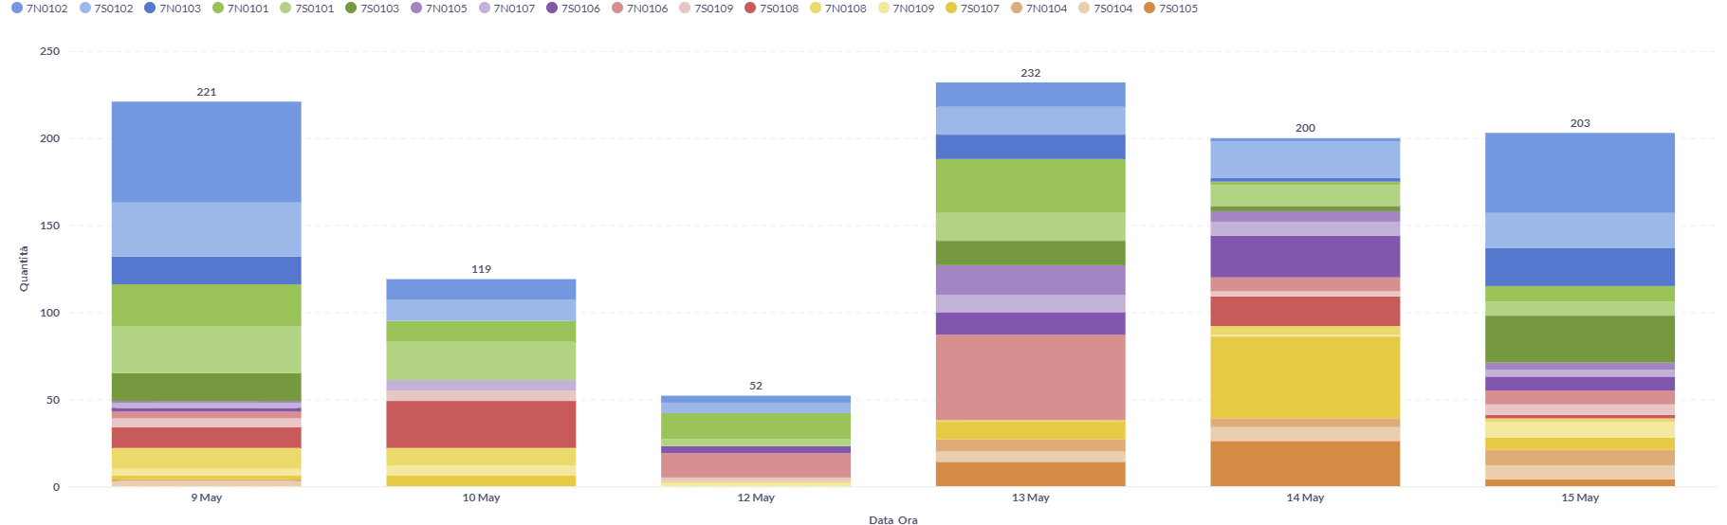
Description:
This chart displays the number of generic alarms triggered for each machine on each day.
It becomes more precise when filtered carefully by machine, alarm type, and specific descriptions. This way, you can determine how many alarms of a particular type and description occurred daily and compare them across different days.
Goals: View the daily quantity of alarms triggered on each machine and enable comparisons between days.

Filters to customize the chart:
- Job
- Time Range
- Machine (multi-select)
- Alarm Type
- Alarm Description

Appunti
Conteggio dei risultati totali e in base al risultato
Contare quanti risultati (ok, ok silent warning, ecc..) abbiamo in totale, quanti in base al tipo e quanti di questi ultimi per ogni macchina.
Conteggio dei risultati
Grafico a torta che mostra per ogni macchina e per ogni risultato la percentuale che ricopre quel tipo di risultato sul totale.

Conteggio tempo medio missione, durata massima, numero di micro-missioni e secondi totali per ogni macchina e per ogni risultato
Quanti secondi in media, quanti secondi in totale e il numero di eventi sono accaduti complessivamente per ogni macchina e per ogni evento.
Conteggio dei tempi
Per ogni macchina e risultato vedo qual è il tempo medio che ci vuole a compiere la micro-missione così che io veda quando è molto elevato e io possa ad andare a investigare meglio.
Giorni e orari per ogni macchina e risultato dato il codice il tipo di risultato
Quali giorni e ore corrispondono a un tipo di risultato mostrando anche la durata media che ci vuole per superare quella micro-missione con quel tipo di risultato.
Giorni dato risultato
Grafico a barre che mi mostra la durata media e il giorno dato un risultato specifico. Utile se accompagnato con grafico sopra perché questo mi da tutti i giorni in cui è accaduto quel risultato. Io posso quindi sopra notare nel complessivo e qua andare ad indagare meglio avendo poi la data a disposizione.

Numero missioni totali per macchina
Mostrare per ogni macchina quante missioni sono state svolte così da capire quali lavorano di più e quali di meno.
Numero Missioni Giornaliere
Per ogni macchina vedo quante missioni sono state svolte.

Numero missioni giornaliere totali per macchina
Mostrare per ogni giorno e per ogni macchina quante missioni sono state svolte così da capire l’andamento giornaliero di ognuna nell’arco del tempo.
Numero Missioni Giornaliere
Per ogni macchina e per ogni giornata vedo quante missioni sono state svolte.

Numero missioni orarie orarie totali per macchina
Mostrare dando un giorno specifico per ogni ora del giorno e per ogni macchina quante missioni sono state svolte così da capire l’andamento giornaliero di ognuna nell’arco del tempo.
Numero Missioni Giornaliere
Dando un giorno specifico per ogni macchina e per ogni ora vedo quante missioni sono state svolte.

Stato Batteria nell'Arco del Tempo per ogni Macchina
Vedere il cambiamento della percentuale delle batterie per ogni macchina per ogni momento fornito
Andamento batterie
Grafico lineare che mi mostra i picchi più sostanziosi delle batterie nel tempo

Ore di lavoro tra un problema e l’altro mean time to repair
Dopo quanto torno a lavorare se succede qualcosa mean time between fail
Numero di interruzioni giornaliere

